User Requirement Specification (URS)



Real-time Analytical Monitoring Application (RAM)

|  |  |  |  |
| --- | --- | --- | --- |
|  | |  | |
| Document Reference: | | RAM/TURS | |
| Project: | | Real-time Analytical Monitoring Application | |
| Document Title: | | Real-time Analytical Monitoring Application (RAM) User Requirement Specification (URS) | |
| Version: | | 2.2 | |
| Date: | | 1-Dec-2018 | |
| Author:  Reviewers:  Approved and Signed off by: | | Balasubramanian Narasimhan (PT07 ISS)  Kaung Myat Bo (PT07 ISS)  Gao Zhiyu (PT07 ISS)  Nay Lin Aung (PT07 ISS) | |
|  | |  | |
|  | |  | |
|  | |  | |
|  | |  | |
|  | |  | |
|  | |  | |
|  | |  | |
|  | |  | |
| **©** 2001  The information contained in this document is the property of ISS. The contents must not be copied in whole or in part for purposes other than which it has been supplied without the consent of ISS, or, if it has been furnished under contract to another party, as expressly authorised under that contract, then ISS shall not be liable for any errors or omissions. |  |
| ***Institute of Systems Science, 25 Heng Mui Keng Terrace,***  ***Singapore 119615*** | |

Version History Record

|  |  |  |  |
| --- | --- | --- | --- |
| Version | Review & Approval Form Number | Date | Brief description of amendments and affected pages, paragraph |
| 1.0 | RAM/TURS | 18/4/2018 | First Issue |
| 1.1 | RAM/TURS | 10/5/2018 | Incorporated comments received during the 1st audit review and presentation |
| 1.2 | RAM/TURS | 10/6/2019 | Incorporated details received during the discussion held with the client |
| 1.3 | RAM/TURS | 19/8/2018 | Incorporated comments received during the internal review meeting |
| 2.0 | RAM/TURS (Baseline Version) | 5/9/2018 | Singed-Off by ‘Soe Pyae/SERIS’ on 5-Sep-2018 |
| 2.1 | RAM/TURS | 20/11/2018 | Updated URS based on the revised set of Requirements received from the client |
| 2.2 | RAM/TURS | 1/12/2018 | Clean-up URS based on the revised set of requirements for further circulation and review; elaborate further on all of the outstanding requirements |
| 2.3 | RAM/TURS |  | Incorporate the review comments |
| 3.0 | RAM/TURS (Baseline Version) |  | Singed-Off by ‘Soe Pyae/SERIS’ on x-Xxx-201x |

Table of Contents

1. INTRODUCTION 5

1.1 Background 5

1.2 Objectives 5

1.3 Organization 5

1.4 Scope 5

1.5 Out of Scope 5

1.6 Definition of Terms 6

1.7 Definitions, acronyms and abbreviations 6

2. OVERVIEW OF REQUIREMENTS 7

2.1 Introduction 7

2.2 System Perspective 7

2.3 System Functions 8

2.4 System Characteristics 8

2.5 User Characteristics 9

2.6 General Constraints and Assumptions 9

3. FUNCTIONAL REQUIREMENTS 11

3.1 Raw/Source Data Packets 14

3.2 Functional Requirements 15

3.3 User Interface Requirements 18

4. Non-FUNCTIONAL REQUIREMENTS 19

4.1 Non-Functional Requirements 19

# INTRODUCTION

## Background

The Solar Energy Research Institute of Singapore (SERIS) conducts research, development, testing and consulting on solar energy technologies and their integration into power systems and buildings. SERIS is globally active but focuses on technologies and services for tropical regions, in particular for Singapore and South-East Asia.

The aim of the project is to develop a cloud-based platform for integrating and managing real-time Analytical Monitoring of PV systems performance - from small rooftop systems to large ground-based PV power plants in the multi-MW range across different climate zones. Collected data will be used for extensive research programmes on yield projections, which are of vital importance to project developers as well as investors and degradation studies of PV modules & systems.

The work is organized in 3 different sub projects

1. Web portal – A web portal for users to access the application components
2. Central Data Management – A cloud based application that can record, transform and report the data sent from PV systems.
3. SERIS Interface – The interface between the application and SERIS central monitoring system which. This interface enables communication and interaction between the proposed application and the SERIS Central Monitoring system.

This document is to present the user requirement specification for the Real-time Analytical Monitoring Application – RAM, i.e. the project

## Objectives

The objectives of this document are to:

1. define the functional requirements for the Real-time Analytical Monitoring Application;
2. define the non-functional (i.e. operational and quality) requirements that would be necessary to support the functional requirements;
3. identify the necessary requirements that would facilitate the future modification of the application and
4. Provide the basis for the development of the system.

## Organization

Section 1 gives an introduction to this document. Section 2 presents an overview of requirements for the system or application. The functional requirements are presented in Section 3 and section 4 describes the operational and quality requirements.

## Scope

This user requirement specification is solely concerned with the development of the Real-time Analytical Monitoring Application and identifying the necessary requirements that would facilitate the future modification of RAM application. For the purpose of this document the Real-time Analytical Monitoring Application is referred as the application or simply ‘RAM’ interchangeably but both refer to the same.

The financing, availability and provisioning of the AWS Service components are agreed to be handled and taken care by the client, i.e. SERIS.

## Out of Scope

The interface to SERIS ‘Central Monitoring System’ is being scoped out of this RAM Application. The SERIS internal team will look into this at a later point-in-time, as long as the data is available and accessible in the cloud.

## Definition of Terms

The following terms have special meanings within this document:

1. The word ***shall*** implies a mandatory requirement.
2. The word ***should***implies a desirable requirement.
3. The word ***will*** implies a mandatory requirement outside the scope of this document.
4. The word ***may*** implies a desirable requirement outside the scope of this document.

## Definitions, acronyms and abbreviations

The following terms have special meanings within this document:

* Acronyms and abbreviations
* SERIS – Solar Energy Research Institute of Singapore
* RAM – Real-time Analytical Monitoring
* RAMA – Real-time Analytical Monitoring Application
* PV – Photovoltaic, systems that converts solar energy into electrical energy
* IoT – Internet of Things
* CMS – Central Monitoring System, The SERIS/in-house central monitoring system
* Definitions
* Devices – The PV systems that are required to be monitored
* Sensors – The sensors attached to each of these devices that constantly measure certain characteristics.
* Station – A station holds a set of devices that needs to be monitored. These devices are said to be tagged to that specific station.
* Web Portal – The component of the system that can be accessed via a browser by end user
* Cloud Computing - Cloud computing is an information technology (IT) paradigm that enables ubiquitous access to shared pools of configurable system resources and higher-level services that can be rapidly provisioned with minimal management effort, often over the Internet. Cloud computing relies on sharing of resources to achieve coherence and economies of scale, similar to a public utility
* Both ‘***Fast Data’*** and ‘***per second data***’ refer to one and the same. Hence, these two terms can be used interchangeably without altering the meaning.
* Both ‘***Slow Data’*** and ‘***per minute data***’ refers to one and the same. Hence, these two terms can be used interchangeably without altering the meaning
* Both ‘***Device Health***’ and ‘***per minute health data***’ refers to one and the same. Hence, these two terms can be used interchangeably without altering the meaning

# OVERVIEW OF REQUIREMENTS

## Introduction

The aim of the project is to develop a cloud-based platform for integrating and managing real-time Analytical Monitoring of PV systems performance - from small rooftop systems to large ground-based PV power plants in the multi-MW range across different climate zones. Collected data will be used for extensive research programmes on yield projections, which are of vital importance to project developers as well as investors and degradation studies of PV modules & systems. Following are the three main streams of the project

1. Web portal – A web portal for users to access the application components
   1. User Management
   2. Station Management
   3. User 🡸 🡺 Station Mapping
2. Central Data Management – A cloud based application that can record, transform and report the data sent from PV systems.
   1. Data Capture – Cloud based components that captures and records the incoming data (both structured and unstructured) sent from sensors
   2. Reporting – Cloud based reporting component that performs back-end analytical calculations and make it available for front-end reporting and as well as for future interfacing with SERIS’s in-house central monitoring system

## System Perspective

The current application is actually an incremental development of the whole application. They were developed as smaller increments to an existing code. One has to manually intervene and re-write most or part of the code as and when a new device is to be incorporated into SERIS landscape. This could be a simple configuration change which could involve minor changes to the existing code. On the other hand it could drive a drastic change to the existing code to suit to a specific new device to be introduced into SERIS landscape. The primary objective of the system is to have soft configurable parameters that allow introducing and integrating new devices with in the SERIS landscape. Following are some of the high level benefits to be delivered by the proposed system.

* Single and Centralized platform for users to process the structured data from remote stations.
* Automated data capture for the structured and semi structured parameters.
* Interface with other backend systems within the organization, in this integration with SERIS central monitoring system. A soft implementation of making the data available on the cloud for SERIS internal applications
* Audit trail capability of the incoming data
* Transformation of unstructured data into structured data.
  + During subsequent discussions with the client, the client has revised the requirements.
  + The data from devices will be in the form of JSON files. They have to be stored in the same JSON format.
  + RAM application need not translate it further into any form of structured data. They will be maintained in JSON format with in the RAM Application.
* Analytical reporting of the stations and devices
  + Real time dashboard
  + Historical charts

## System Functions

System functions to be implemented are:

1. Browser Interface – Access to the application via standard browser interface
2. User Login & Access control – Relevant components are exposed and are accessible by the user, delivering effective user access.
3. Application Administration – Perform setup, configuration and other supervisory / administrative functions to be carried out by the administrators, primarily focused on application level components
4. User Management
   * + Personal Management
       - This requirement is to be implemented in the form mapping users to a set of stations, which can be dynamically managed via the RAM application.
       - Mapping of users to select set of stations (None, one or more stations).
       - Under ‘User Management’, the selected user can be assigned a specific set of stations.
     + User Role Management
       - This requirement is to be implemented in the form mapping users to a pre-defined set of roles, in this case either ‘Administrator’ or ‘System User’ via a simplified user interface(drop down selection)
5. Station Management.
6. System Administration – Perform setup, configuration and other supervisory / administrative functions to be carried out by the administrators, primarily focused on system / infrastructure level components
7. System Setup
8. System Configuration Management
9. Central Data Management
10. Data Capture
11. Reporting
    * + Real time dashboard
      + Historical charts (Daily, Monthly & Yearly)

## System Characteristics

The system has below listed characteristics

* RAM to be built on Cloud technology to offer high degrees of agility and the ability to collect high volumes of data in real time
* RAM allows PV system device(s) to generate very high volumes of unstructured data. This could typically be unstructured data sent at every second and every minute interval(s) from a variety of devices and store it in Cloud Database. These devices are spread across various industrial and remote sites that will stream data into the application which is to be stored with in the cloud database infrastructure
* RAM allows admins to configure and incorporate cloud-based system to reduce the cost of maintaining servers, to avoid data losses and to simultaneously access the system from multiple internet connected devices (computer, tablet, mobile phone)
* A default admin (super-user) user account will be setup during the installation. The admin will come with a set of pre-configured rights and privileges. Unlike other user accounts this account cannot be deleted/deactivated from the system.

## User Characteristics

The users have below listed characteristics

* Users will use the application via browser interface. The browser version supported are Chrome, Mozilla Firefox, Safari, Microsoft Edge, and Internet Explorer 11 and above. In general we expect the client to upgrade their browser to recent version if not the latest version to maintain compatibility with the application.
* A user can only login from at most one system at any point in time. Concurrent login for the same user is not allowed, in which case the previous session will be automatically logged out

## General Constraints and Assumptions

The following are certain general assumptions and constraints of the intended application.

* Base version of application with following set of interfaces will be available.
* All partner systems will provide the required interface to integrate with Cloud based Real-time Analytical Monitoring of Photovoltaic Systems.
* Required Hardware and Software infrastructure will be made available in SERIS. The server and database are stored, managed and maintained by the SERIS, which is also responsible for maintaining the system and ensuring its qualification.
* The Sensors and Readers are installed at the Remote site, but the software, server and database are hosted by the system. The data are collected, stored and managed by the system whilst the SERIS has access to the data through a secure web interface.
* Application Development would be done by the MTECH SE25-PT07.
* Sensors should have a built-in data storage capability so that they can also act as data loggers. Sensors continuously collect and buffer data, even during network outages and power cuts. The buffered data should then be sent to the host server when the connection is re-established.
* All new stations created are to be approved and will undergo a manual configuration of the associated rules by the SERIS administrator.

The following are retired functionalities that have been marked as ‘Out-of-scope’ of the RAM Application.

* Interface to SERIS/Central Monitoring System.
  + Interface to SERIS/Central Monitoring System is outside the scope of the RAM Application.
  + The client has subsequently requested us to amend this requirement to simplify the administration and cater for a better user experience.
    - The ‘SERIS Interface’ is not a physical interface built within the RAM application.
    - This interface is a soft implementation of data availability to SERIS central monitoring system.
    - The SERIS central monitoring system will be amended by SERIS to directly interface with the data available in the cloud for its monitoring purposes.
    - The RAM application is expected to capture device data, record them in the cloud storage and make the data available in the cloud for SERIS central monitoring system.

# FUNCTIONAL REQUIREMENTS

This section describes the functional requirements of the RAMA. Figure 1 below present an overview of the system, showing the main components of the application and the roles of the users.

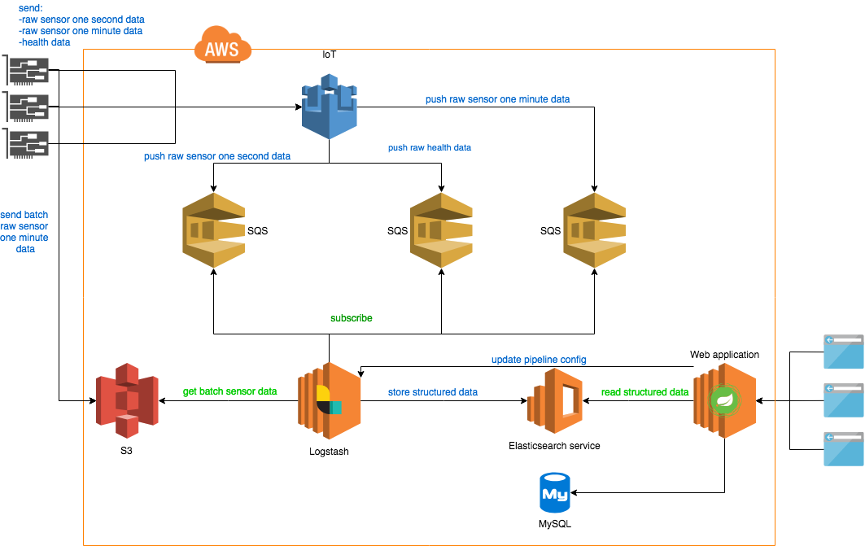

Figure 1: System Overview

The below is Requirements level Use Case Model for the Application for understanding the features application will provide.

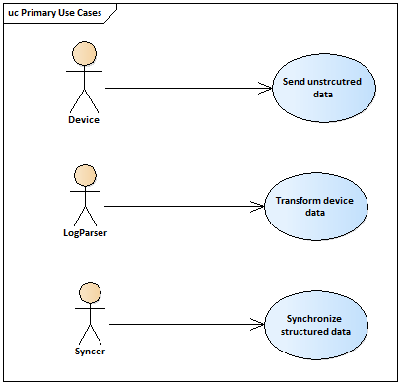

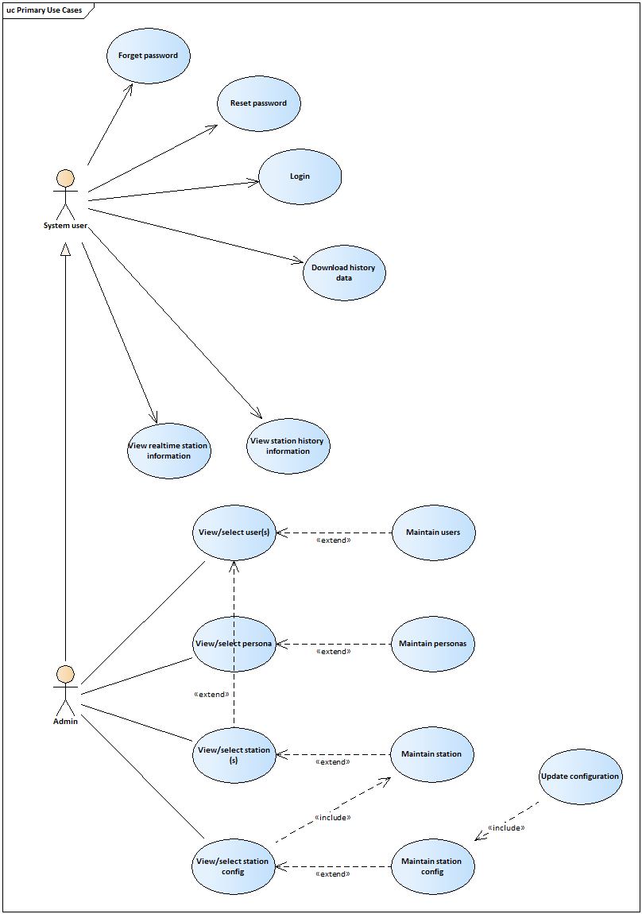

Figure 2: Primary Use Cases

## Raw/Source Data Packets

The source data consist of sensor data & health data, both of which come in the form of JSON format. There are 3 types of data that will be sent by the stations. They are ‘fast data’, ‘slow data’ and ‘device health’.

* **Fast Data:** Sensor data from devices are buffered and sent to RAM Application at per second interval. The ‘fast data’ is used for real time monitoring of station(s) within the user’s dashboard.

Volume per device/per day 🡺 60seconds x 60 minutes x 24 hours

🡺 86,400 records / per day / per device

* **Slow Data**: Sensor data from devices are buffered and sent to RAM Application at per minute interval as well

Volume per device/per day 🡺 60 minutes x 24 hours

🡺 1,440 records / per day / per device

* **Device Health**: Health data from devices are buffered and sent to RAM Application at per minute interval

Volume per device/per day 🡺 60 minutes x 24 hours

🡺 1,440 records / per day / per device

* In summary the RAM Application is expected to receive 89,280 records from each of the device/station on a daily basis under normal operating conditions
  + Per second senor (fast) data 🡪 86,400 records
  + Per minute sensor (slow) data 🡪 1,440 records
  + Per minute health (device health) data 🡪 1,440 records
* The typical characteristics of the data packets are
  + Data sent in JSON format
  + Dynamic variable length data, dependent on the device in JSON format
* The data is to be recorded and stored within the cloud platform in an indexed manner to support easy access and retrieval on a per day basis. The data is to be captured and stored on a daily basis in separate files for each of the three types of data.

## Functional Requirements

This section describes in brief on the functional requirements of RAM. Although the technical requirement does not cover each and every aspect of the intended functionality at this point in time; it does give an overview of the functionality to be implemented by RAM application. The implementation details of the functionality may change based on the implementation technology choice, infrastructure and software components.

### Browser Interface

Users access the application’s web-portal via a standard browser interface with an active internet connection. The web-portal should be user-friendly and is capable of performing complex operations by accessing the data stored in the cloud.

### User Login and Access Control

The system allows authorised user(s) to access the application. The user is required to provide username and password. It specifies the access and usage privileges of authenticated users and client applications.

After authentication user will have access to main menu. Availability of menu functions depends on user’s level of access. This is explained in detail under the section ‘User/Access Control Mapping’

The system allows access to relevant application components and functionalities based on the users permissions. This function allows the user with appropriate permissions to view and extract reports for the stations to which he/she has been authorised within the application. This is managed in the form of ‘User | Station’ mapping which is explained in details under a separate heading.

A user can only login from at most one system at any point in time. Concurrent login for the same user is not allowed, in which case the previous session will be automatically logged out for that user.

### Application Administration

Perform setup, configuration and other supervisory / administrative functions to be carried out by the administrators, primarily focused on application level components

#### **User Management**

A user needs to be registered before he/she can get access to the system. The System should allow the Users to create, edit, copy and delete Individual Users, who will login and access the application.

#### **User/Access Control Mapping**

In order to simplify the administration and cater for a better user experience, the requirements have been simplified to cater for 2 sets of pre-configured roles; they are ‘Administrator’ and ‘System User’.

The current requirement is to a have 2 sets of pre-configured roles (i.e. ‘**Administrator’** and ‘**System User’**). The system should allow the user to choose between one of these 2 roles, ideally via the ‘User Management’ interface.

#### **Persona**

Persona refers to the user job designation or role within SERIS. As such a user can be tagged to a specific persona. The persona can be one of the personas which have already been created within the RAM Application. The administrators should also be able to create personas dynamically and tag it to users during user management screens.

#### **Station Management**

A station is a site that has a set of IoT devices tagged to them. The station needs to be registered before it can send data to the system. The System should allow the Users to create, edit, and delete stations to which the IoT devices are tagged to within the RAM application. The lowest level of granularity of devices/sensors has been revised to **stations**, instead of individual devices/sensors.

The System allows the user with appropriate permission to browse list of all stations existing in the system.

#### **User 🡸 🡺 Station Mapping**

The System should allow the administrators to create, edit and remove stations mapped to individual users.

#### **Forgot password**

This option allows an existing user to reset password, in case he/she is not able recollect the current password. A registered user can request for a password reset link to be sent to his/her registered email address. Such a request should send an email to the user which contains the link to reset his/her password. Using this link, the user will be able to choose and assign a new password.

### System Administration

Perform setup, configuration and other supervisory / administrative functions to be carried out by the administrators, primarily focused on system / infrastructure level components. The user should be provided with 2 sets of technical documents catering to the system administration functionalities. They are ‘System Setup’ and ‘System Configuration Management’ documents.

#### **System Setup**

The System allows to be built on Cloud technology to offer high degrees of agility and the ability to collect huge volumes of data from the enterprise and beyond. This function facilitates the initial setting up of the application’s high level infra-structure components and its details. A high level technical document is to be provided to cater for this functionality with the assumption that such a document is meant for system administrator’s reference

#### **System Configuration Management**

The System allows admins to configure and incorporate cloud-based monitoring system to reduce the cost of maintaining servers, to avoid data losses and to access the system from multiple internet connected devices (computer, tablet, mobile phone) in parallel manner. A high level technical document is to be provided to cater for this functionality with the assumption that such a document is meant for system administrator’s reference.

### Central Data Management

A central component of the application which manages

* Incoming data from IoT devices
* Preparation of analytical data and Reporting requirements
* No data transformation is expected to be carried out by the RAM Application.

#### **Data Capture**

The System allows capturing unstructured data sent from IoT devices in real-time.

* The data sent from devices will be in the form of JSON files. They have to be stored in the JSON same format.
* RAM application need not translate it further into any form of structured data. They will be maintained in the same JSON format with in the RAM Application.

#### **Data Download**

The System should facilitate an easy way to download the data from the cloud into their local PC. The user should be able to select a specific station or all of the station(s) tagged to that user. The user should be able to customize the download further by specifying a date range for the data download. The downloaded data will follow the JSON format, as received from the station.

### Real-time Dashboard

There should be option for users to easily access the dashboard. Ideally there the dashboard is to be divided into 3 sections, the ‘**map’**, ‘**health’** and ‘**sensor’**.

The ‘**map’** section displays the station(s) attached to the user on a map. The user should be able to interactively navigate through the map that is presented. The user should be able to select a specific station on the map by a simple click of the mouse.

The ‘**health’** section displays a summary of health status of the stations/devices attached to the user in real-time. Since the health data is sent to the RAM application on a per-minute basis, the health summary is to be refreshed with the same frequency of the incoming health data.

The ‘**sensor’** section displays the data sent from sensors attached to the station in real-time. This section should work in-sync with the ‘map’ section. The ‘sensor’ section displays the selected station’s sensor data. Since the sensor data is sent to the RAM application on a per-second basis, this section is expected to be refreshed on a per-second basis. The typical parameters required to be displayed within the real-time dashboards are

* Ambient Temperature
* Module Temperature
* Humidity
* Wind Speed
* Wind Direction
* Active Power readings
* Irradiance readings
* Pyranometer readings

### Reports

The data should be available and accessible by users in the form of reports, charts, and graphs. The users are able to customize these reports further.

A single unified line graph is required to be provisioned for concise visualization. The graph should be customizable, dynamically and interactively for a selected station. The user can only select from the stations that he was previously tagged to within the RAM application. The user should be able to choose a specific day or month or year from the past and from there on further customize it. The customization requirements are daily, monthly and yearly chart. The typical parameters required to be displayed within the chart are

* Module Temperature
* Humidity
* Ambient Temperature
* Irradiance

### System Alerts and Notifications

The RAM Application will send certain alerts to notify the users of important or time-sensitive information captured by the application, especially around device health status.

Users have requested that an alert be triggered and sent in case of device failures. The application will receive device failure information in real-time from an external device monitoring application managed by SERIS. The RAM application in-turn makes use of this information to trigger an alert and notify the user of such device failures.

The device health code sent by the station indicates the health status and error code. Ideally we should be receiving a ‘1’ meaning device in good health and there are no errors. In case the value is not ‘1’ then an alert to be trigger by the RAM application to the registered user tagged to that station. This will help SERIS to intervene and take corrective action in a timely manner.

### Auditing and Traceability

The RAM Application is expected to capture and record certain key events and activities performed with in the system. These include

* User Login/Logout details (Session details)
* User Management details, specifically creation and deletion of user accounts
* Station Management details, specifically creation and deletion of stations

The audit data captured should be made available and accessible to SERIS administrators. They should be accessible interactively or through a download option for auditing the RAM application’s critical functionalities.

## User Interface Requirements

The 'User Interface specification' is documented and available as a separate document in ‘\SPEC\REQUIREMENT\UIS\UIS.docsx’.

# Non-FUNCTIONAL REQUIREMENTS

This section describes the functional requirements of the RAM.

## Non-Functional Requirements

This section describes in brief on the functional requirements of RAM.

* All partner systems will provide the required interface to integrate with Cloud based Real-time Analytical Monitoring of Photovoltaic Systems
* Sensors should have a built-in data storage capability so that they can also act as data loggers. Sensors continuously collect and buffer data, even during network outages and power cuts. The buffered data should then be sent to the host server when the connection is re-established
* The RAM Application is hosted in the cloud provided by SERIS. Any performance measurement is based on the subject to the availability and performance of the cloud platform which is managed by SERIS
* The RAM application should be available and accessible by users
* The first 3 months of application launch window is to be treated as performance stabilization period, during which uptime & performance measurements are not applicable.
* The RAM application uptime should not fall below 90% measured quarterly, post-performance stabilization window.
* The RAM application is expected to support at least 100 devises during the launch
* The RAM Application should be able to support both regular data and health check data sent from devices
* The raw data captured by the RAM Application should be accessible with in an acceptable latency of 15mins in its native/raw format
* The transformed data should be accessible with in an acceptable latency of 60mins from the time it is received by RAM Application.
* Users are expected to use compatible browser. The actual browser and version from will be communicated separately
* No concurrent login sessions are allowed with in the application